FOUNDATION FOR VIRTUAL AND AUGMENTED REALITY SYSTEMS
Lecture31
Lec-31: Other Senses & Full Immersion
Hello and welcome to the NPTEL MOOC's course on Foundations of Virtual and Augmented Reality Systems. We are going to start discussion on a new topic that is our other senses other than visual and auditory sense and their role in full immersive experience. So, previously what we have covered. We have talked about the relation between human physiology and the usage of AR-VR systems. That was at the beginning of this module.
Then we talked about in detail, in some detail, not too much detail, but in some detail, the human visual perceptual system and how the knowledge of human perceptual system, visual perceptual system helps in building better XR systems. Subsequently, we talked about the human auditory system and how it helps create immersive experience in XR in addition to the visual perceptual system. Now, we know that we have five senses plus a sixth sense. What are those five senses?
Visual, auditory, touch sense, smell, taste and the sixth sense as we have discussed earlier is the proprioceptive sense or proprioception. So, in this lecture, we are going to cover the remaining senses that are touch, taste, smell and proprioception and their relation to XR. So, how do we perceive them? What is the physiology that enables us to perceive?
these different things like touch or taste or smell and how that knowledge helps in building better XR systems. So, we are going to cover that in this lecture. Let us begin with the sense of touch and proprioception. These two are connected. So, we will first talk about them.
Like the human visual perceptual system or human auditory perceptual system, we have the human somatosensory system. Now this is another sensory organ, the somatosensory system. It handles touch, proprioception, and kinesthesis. Now proprioception, we have already talked about it before. This is nothing but awareness of the pose of each movable human body part such as legs, arms, fingers, tongue, mouth and lips, whichever can be moved relative to other body parts.
So, when we are moving any of these body parts, we do it consciously with full knowledge of what we are doing, that awareness is called proprioception or our sixth sense. Kinesthesis, on the other hand, provides information on velocities, acceleration, and forces while moving these body parts. So, proprioception is awareness of movement. Kinesthesis is awareness of various parameters associated with the movement.
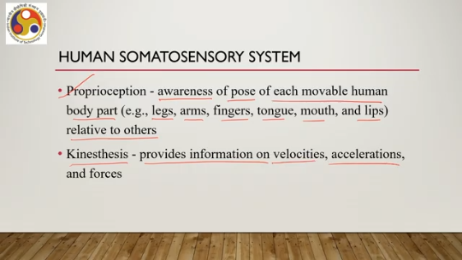
Now, in the human somatosensory system, we have at least nine major kinds of receptors, out of which six are fully devoted to touch senses, the sense of touch, and the remaining three are devoted to proprioception and kinesthesis. So essentially, we have this human somatosensory system responsible for our sense of touch as well as proprioception and kinesthesis. Let us talk about the touch receptors. So these receptors are embedded in the skin.
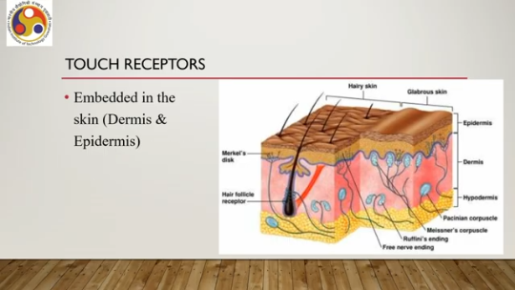
Now skin has different layers such as epidermis, dermis, and hypodermis. Now these These receptors, touch receptors, are embedded in the dermis and epidermis layers, that is, the first and second layers which are just below the skin. As you can see, there are many such receptors, at least six. such as Merkel's discs, hair follicle receptors, free nerve endings, Ruffini's endings, Meissner's corpuscles, Pacinian corpuscles, and so on.
So, all of these you can see are part of either the dermis or epidermis layer of the skin. For proprioception, we use a different set of receptors, although they are part of the somatosensory system. Now, one of those are the muscle spindles, which are embedded inside each muscle. These spindles report to the brain on changes in length. So, whenever there is some movement, some change in length happens in those muscles, and those changes are reported to the brain.
by these muscle spindles which are kinds of receptors for the proprioception sense. Then we have Golgi tendon organs. These are embedded in tendons, which are tough bands of fibrous tissues connecting muscles to bones, and these tendon organs are supposed to report changes in muscle tension. which are associated with movement of muscles. Also, there are joint receptors which lie at the joints between bones.
So, we have receptors at muscle, muscle receptors at connection between muscle and bone, and also at bone joints we have receptors, joint receptors which help coordinate muscle movement and they provide information on relative bone positions. So, all these receptors, so-called receptors, help us get a sense of movements in our body parts with respect to other body parts as well as the properties of that movement such as acceleration, velocity, and so on. So, that is in brief what the somatosensory system is that is responsible for
the sense of touch as well as proprioception and how the physiology is there in our body. Now, let us try to understand how it works in terms of a very simple example: suppose our hand touches an object. So, this example will briefly talk about the touch sense although it is equally applicable for the proprioceptive sense. Suppose our hand touches an object. So, then what happens?
So, the somatosensory receptors get activated once the hand touches the object. And those receptors, activation of those receptors, starts a chain of events by sending a signal to the nearest neuron. Then the neuron transmits a message to the next neuron. As we know, there is this neural network meant for transferring neural information from one neuron to another. The same thing happens in our somatosensory system.
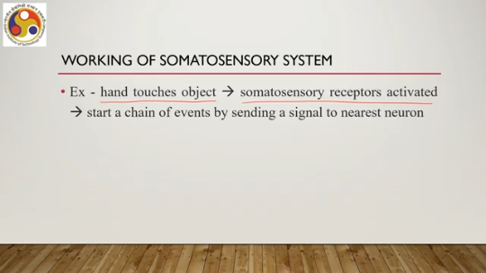
So the receptors receive this input and then transform it to a neural impulse, which gets transmitted through the neural network. from one neuron to the next neuron till the impulse reaches the brain. Now, the brain processes the message, whatever is coming through the neural network, which gives us the touch perception. Also, the brain sends some messages back to the hand in this case via the same pathway. to take corrective motor action if needed, such as removing hand from hot object.
So, it is not only about receiving but also acting on the input. So, once the information is processed, then the brain also sends some commands to perform the motor action necessary for the situation. So, that is how the somatosensory perception works. Now, a major part of the somatosensory perception is called haptic perception, which is the perception of the overall geometric shape of objects. Now, this overall shape of objects can be inferred through haptic exploration.
which involves object handling. So, one is touching, the other one is handling or manipulation of objects to infer the overall shape of the object, geometric shape through haptic perception. That is also very much part of our perception of touch. Now, haptic exploration or the manipulation of geometric objects to infer through our perception process to infer the overall shape of the object. Such explorations can be of six types.
As illustrated in this figure, we have lateral motion texture to perceive the texture of object surface through lateral motion, then pressure, hardness by pinching on the surfaces. We can understand the hardness of the surface. So, lateral motion is meant for texture understanding or texture perception. Pressure is meant for hardness perception. Then enclosure is meant for global shape or volume perception, that is putting our hands around the object in the way shown here.
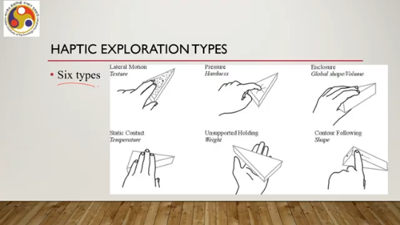
Static contact can lead to temperature perception just by touching the object surface. Unsupported holding can be used to perceive the weight of the object as shown here. And contour following by moving our fingers around the surfaces, we can perceive the shape. So, there are six things that we can perceive using haptic exploration. Those are texture, hardness, shape, temperature, weight, and also shape.
In one case, it is global shape. In another case, it is local shape. And for each of these perceptions, we need to perform a different type of haptic exploration. For example, lateral motion is meant for texture perception, pressure as shown here is meant for hardness perception, enclosure as shown here is meant for global shape perception, static contact meant for temperature perception, unsupported holding meant for
weight perception, and finally contour following is meant for local shape perception as shown here. So, these are means to perceive different geometric properties of objects that are there in our surroundings. So, the perception can be thought of at different levels. One is there are receptors in the human physiology, that is physiology of skin.
Now these receptors help us get input from the real world and then process the information to perceive something through touch. Now to have a better perception, higher level perception along with simply touch, we need to perform some manipulations of objects. Those are called haptic explorations. And as we have just discussed, there can be six such types of explorations to obtain or perceive geometric features, different geometric features. Also, it may be noted that each of these explorations through which we perceive different properties of objects,
involves different kinds of receptors. And also they involve combination of spatial and temporal information. So it is not only spatial information, but also temporal information is involved for perception of the object properties through haptic exploration. Now the overall goal of this haptic exploration is is by integrating the somatosensory signals from this in-hand manipulation, the manipulation of the object as shown in the figure,
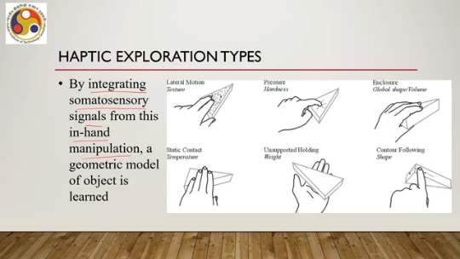
A geometric model of the object is learned in terms of its properties, such as shape, size, weight, hardness, and so on. That is the overall idea of this manipulation. So, when we try to perceive something, we create a model of the object, and to aid our model-building exercise, our mental model-building exercise, we perform haptic exploration. So, as can be figured out from the preceding discussion, clearly this haptic perception
It is very important to create a mental model of the world surrounding us, and it also implies that such mental model creation, which is an essential part of an immersive experience, can be beneficial for better immersive experience. So, this haptic exploration or haptic perception offers an extra dimension to the VR world. We can perceive the world better if we allow haptic exploration in the world.
By letting users feel the virtual environment via the sense of touch or, in other words, via haptic exploration, we can let the users have a better feeling of the virtual world and also help one feel truly immersed in the artificial world. In our real world, when we say that we are immersed in the real world, that involves this haptic exploration as well. And if we allow the same thing in the virtual world, then certainly that will increase the immersive experience, that will better the immersive experience. For example, imagine yourself in a desert in a virtual world, in an artificial setting, seeing the sand and feeling it glide under your feet as you walk.
Now, that is a haptic touch perception. If we want to give a user a true feeling of walking on the sand in a desert, then certainly only visual or auditory perception may not give a complete picture to the user. Instead, if we can add some haptic exploration support in the virtual system through the use of proper hardware and software, that experience will be far better as compared to an experience involving only visual or auditory senses.
Now, when you say we want to provide this touch sensation, it can be provided through engineered devices, and there are many disparate systems to provide the experience. Typically, such devices provide, in the most popular form, force feedback in the form of vibrations from XR applications. So, typically the most popular way of providing touch sensation stimuli as output is through force feedback devices and force feedback, which are quite common in many of the XR systems, particularly VR systems.
For example, force feedback mouse, smart gloves, or body suits which allow the user to experience the force feedback. An interesting example can be the KGS dot view model DV-2, which is a haptic pin array as shown here; as you can see, this part is containing an array of pins, a matrix of pins, which are controlled by the system by the computer. Now, pins are forced
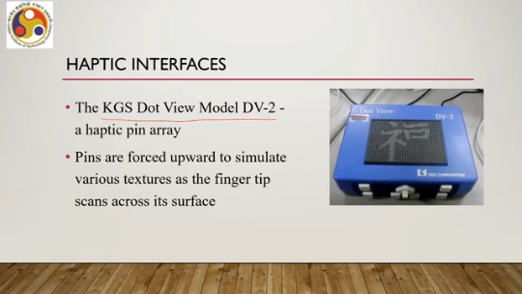
upward to simulate various textures as the fingertip scans across its surface. So, this pin array can be controlled by the computer, and depending on the objects we are dealing with in the virtual world, the corresponding signals will be generated to force the pins upward so that the user gets a feeling of touching an actual object, getting a feel on the fingers or hand. of the texture of the object surface. But this type of pin array device and controlling them precisely to give the realistic feeling of a textured surface, as we can understand, is not very easy,
very difficult, generally difficult and challenging. There can be other ways to resolve this issue. Now, these haptic devices are actively controlled by a computer. However, to give the user the feeling of touching a real object surface while in the virtual world, an alternative can be to rely on real objects to provide feedback to the somatosensory system. So, we can allow the user to use real objects whose virtual avatars are there in the
world, and that is generally considered to be less challenging than actually coming up with a computer-controlled haptic device. Now, this type of real-world object replacing the computer-controlled haptic devices for touch sensation, they are sometimes called tangible user interfaces. Now, when we are trying to implement that alternative, the idea is very simple. We need to make the experience by aligning the real and virtual worlds.
For example, a see-through display such as Microsoft HoloLens which is typically good for mixed reality or augmented reality experience enables users to see and interact with the physical world around. There is no issue with that. Now, the display simply adds virtual objects to the real world or visually enhances real objects. So, when we are
Seeing the real object, we are interacting with it; the computer also sees it through our wearable device sensors, and it detects which real object we are dealing with, Then accordingly it may change something in the view of the real object or it may add virtual objects to the real world. So, that is about the haptic or touch sense and how it can be useful in XR systems. Next, let us move our attention to the idea of taste and smell.
Now, we are discussing them together because generally they are grouped together as chemical senses. Unlike the previous cases where we have used different types of receptors, here chemoreceptors are more important. So, they are generally called chemical senses because the receptors, the chemoreceptors work by chemical interaction with the molecules that arrive on them. So, taste, sense of taste or sense of smell is nothing but chemical reaction of the chemoreceptors with the stimuli that are arriving to the receptors. These chemoreceptors are capable of responding to particular substances at sufficiently high levels of concentration, appropriate amount of concentration rather to speak.
So, chemoreceptors are designed to interact with specific chemicals, specific chemical stimuli. So, not all chemoreceptors are good for dealing with all sorts of chemical stimuli. Unlike the other three senses, say visual, auditory and touch senses, there is much less work, much less research done with respect to the sense of smell and taste and how to integrate them in XR systems. And even fewer electronic devices were made or are being made that display or that actually deal with stimuli.
to nose and tongue which are the body organs responsible for smell and taste. Now let us first try to see what has been done so far in terms of smell interfaces. Now adding scent or smell to films is actually a very old idea. It can be traced back to the early 20th century. During our discussion on history, we talked about various systems.
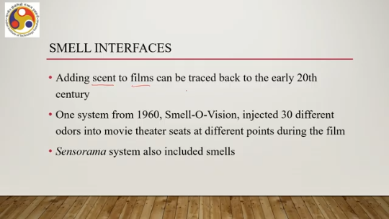
One such system was Smell-O-Vision, developed way back in 1960, which injected 30 different odors, smells, into movie theater seats at different points during the film. Viewers were seated at different points, In the film, depending on the scenery, different odors were sprayed to the seat so that viewers could smell and feel immersed in that particular scene. The other system we talked about, Sensorama, also included smells. So, what does a smell interface look like?
Which actually is meant for providing stimuli to our nose. It usually involves air pumps that can spray chemical compounds into air, could be delivered close to the nose for a personal experience. One such schematic is shown here. So this odor is sprayed. Near the nose using the micropump setup the odor comes to the nose and there are other components which help create this odor.
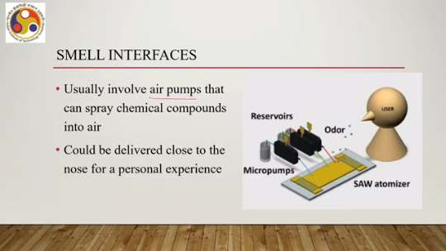
So, for personal experience it is sprayed near the nose of the user or for a social or larger experience it can be delivered on the scale of a room. Say for example, somebody is experiencing VR in a cave system. So, there that is a room and at room level it can be done. But clearly it is generally hard to control the intensity and uniformity of the odor across the room. So, it is relatively easier at an individual scale to generate,
and create the effect as compared to a room level effect. What is typically desirable in such cases is to vary the concentration of odors over a large area so that localization can be performed, which is again difficult to achieve with accuracy. So, with the current state of research, this is generally not very easy to do. Now we can call such systems displays, where the display term is a very generic term, and we can call these smell interfaces olfactory displays. Now they are shown to induce—if it is possible to generate such effects—then they are shown to induce strong cognitive and emotional responses from people.
As per study, it has been found that if we can add this effect in our overall immersive experience along with the other senses, then that can lead to strong cognitive and emotional responses which, makes the experience attractive for the users, makes the experience more immersive and also there is evidence that pleasant odors can help reduce visually induced motion sickness or, in other words, cyber sickness. So, if we add a pleasant odor, then probably the effect of cyber sickness can be reduced to some extent.
Now, let us try to have a quick look at the taste interfaces. Again, like smell, relatively little work has been done on simulating the taste electronically. An example system is shown here, where electrodes are placed over and under the tongue to provide stimulation that simulates the main taste types. So, you can understand the complexity of the setup.
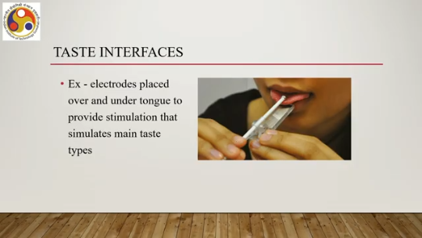
You have to put electrodes over and below the tongue, to provide stimulation that will, in a sense, simulate the effect of taste. It is generally difficult to develop taste interfaces, taste displays, without actually causing people to eat food during the experience which of course is not a very convenient arrangement and generally quite difficult to achieve in practice. So that brings us to the end of this discussion.
Let us summarize what we have learned so far. So in this discussion, we talked about our remaining senses other than visual and auditory senses. So we talked about the touch sense, proprioception, taste, and smell. We have seen how the human somatosensory system is related to perception of touch as well as proprioception. There are several receptors, out of which six are dedicated to touch, three are dedicated to proprioception and kinesthesis.
We briefly talked about haptic explorations and how that helps us perceive the world around us in terms of perceiving the geometric properties of objects around us. And we also discussed how that support, if provided in a VR or XR setting in general, can help increase the immersion and presence. Similarly, we talked about taste and smell. We noted how little research has been done and how complex it is to basically generate the effects of smell and taste.
through cumbersome setups. However, there is little work on it. Some research prototypes are there, but still those are not very popular or commonly used in commercially available VR systems. So, with that, we have completed our discussion on the human factors and XR. In the next lecture, we will be talking about another part of the foundations of the
XR systems, that is, how to build interactive systems. So, what are the stages involved in interactive systems? XR as an interactive system we have already learned, and next we will be talking about interactive XR system development. How to develop such a system? What systematic process to follow?
So, what is the theory and in practice how we can do that? The practice part we will cover using a case study. Some parts of this lecture, in fact, a major portion of this lecture is based on this reference, Chapter 13, Virtual Reality by LaValle. If you are interested, you can go through the chapter and get more details on those topics that are covered in this lecture. So, looking forward to seeing you in the next lecture.
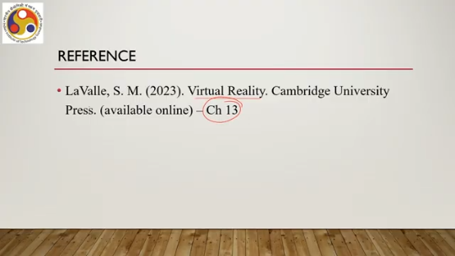
I hope you have followed the concepts. You are able to follow the concepts discussed here. Enjoy the topics. Looking forward to meeting you again in the next lecture. Until then, thank you and goodbye.
Happy learning.

